Joins and Subqueries

This is a checkpoint worth 5% Due 22nd August, push your work to Git (Lab or Hub) by 5pm.

For the following exercises, please use the database shown below (this is the Microsoft “Pubs” database). Familiarise yourself with the database diagram, then write the indicated queries. Please read the instructions for each group of queries carefully.

You can find the scripts to create and populate the tables on the I: drive.

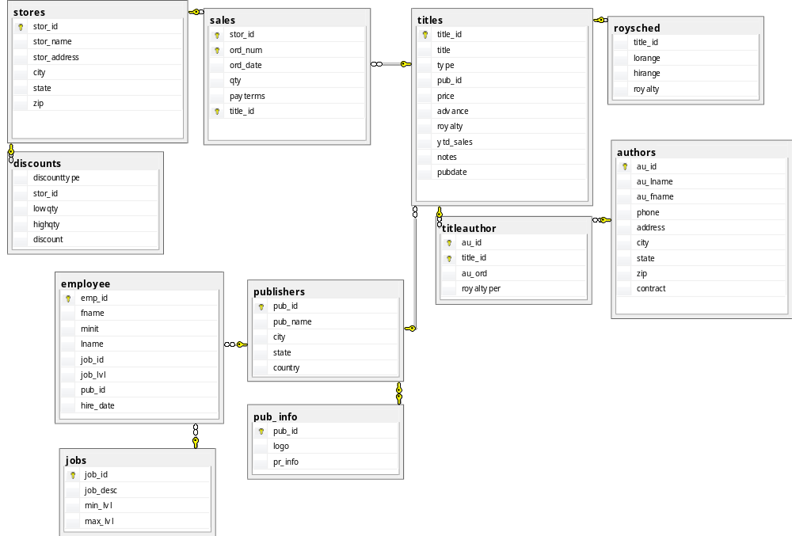

These queries can be written using joins or subqueries, please make sure you use a mixture of both.

- List the titles and prices of all books that have the cheapest price.
- List all titles that have sold more than 40 copies at a single store.
- List all authors who have not published any books.
- List all the publishers who have published any business books.
- List all authors who have published a “popular computing” book (these books have type = 'popular_comp' in the titles table).
- List all the cities where both an author (or authors) and a publisher (or publishers) are located.
- List all cities where an author, but no publisher, is located.
- List all titles that have sold no copies.
- List the title and total sales of each book whose total sales is less than the average totals sales across all books.

- List the publishers, and the number of books each has published, who are not located in California.
- For each book, list the number of stores where it has been sold.
- For each book, list its title, the largest quantity of it sold at any one store, and the name of that store.
- Increase by two points the royalty rate for all books that have sold more than 30 copies total.

Query 14: Challenge Problem. Think carefully about what set you need to produce to answer this question, and what tables you need to join to produce that set.
- List all types of books published by more than one publisher.

